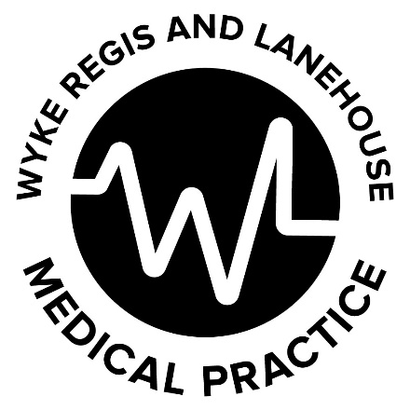
What is blood pressure?

Follow this link for more information https://www.bhf.org.uk/informationsupport/risk-factors/high-blood-pressure
Blood pressure is the pressure of blood in your arteries – the vessels that carry your blood from your heart to your brain and the rest of your body. You need a certain amount of pressure to get the blood moving round your body.
Your blood pressure naturally goes up and down throughout the day and night, and it’s normal for it to go up while you’re moving about. It’s when your overall blood pressure is consistently high, even when you are resting, that you need to do something about it.
T hough your arteries are stretchy to cope with your blood pressure going up and down, if you have high blood pressure, your arteries lose their stretchiness and become stiff or narrow. The narrowing makes it easier for fatty material (atheroma) to clog them up.
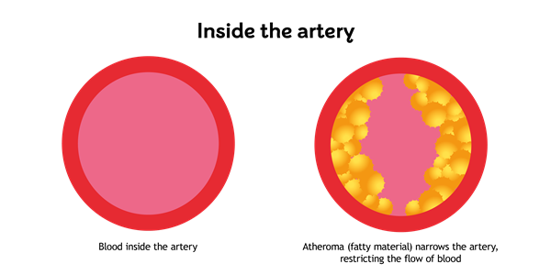
If the arteries that carry blood to your heart get damaged and clogged, it can lead to a heart attack. If this happens in the arteries that carry blood to your brain it can lead to a stroke.

What is a normal Blood pressure reading?

Average home Blood pressure readings should be less than 135/85 whilst clinic Blood pressure readings should be less than 140/90. This is in recognition of the fact that the BP is often mildly elevated in a clinic setting.

Home blood pressure readings are felt to be more accurate than clinic Bp readings.If you have Chronic kidney disease or diabetes you may have a slightly lower target

What causes high blood pressure?
There isn’t always an explanation for the cause of high blood pressure, but most people develop high blood pressure because of their diet, lifestyle or medical condition.
Sometimes high blood pressure runs in families and can also worsen with age. People living in deprived areas are at higher risk of having high blood pressure, and it is also more common if you are of black African or black Caribbean descent. Even in these cases, you may still be able to improve your blood pressure by changing your diet and being active.
These can all increase your risk of getting high blood pressure:
- Drinking too much alcohol
- Smoking
- Being overweight
- Not doing enough exercise
- Eating too much salt
In a very small number of people, the cause of high blood pressure can be identified. Doctors sometimes call this secondary hypertension. For example, an abnormal production of hormones from the adrenal glands can lead to high blood pressure. If your doctor gives you treatment for the hormonal condition, your blood pressure should then return to normal.
Other causes of secondary hypertension include:
- kidney disease
- diabetes, and
- some medicines, such as oral contraceptives and some over-the-counter and herbal medicines.
If you are concerned that any medicine or remedy might affect your blood pressure, ask your doctor or pharmacist about it.

Here are 10 lifestyle changes you can make to lower your blood pressure and keep it down.
- Lose extra pounds and watch your waistline. ...
- Exercise regularly. ...
- Eat a healthy diet. ...
- Reduce sodium in your diet. ...
- Limit the amount of alcohol you drink. ...
- Quit smoking. ...
- Cut back on caffeine. ...
- Reduce your stress.

